**Lab # 7**

**Sequence Diagram**

**And**

**Collaboration Diagram**

**Objectives:**

Draw sequence diagrams OR communication diagrams with advanced notation for your system to show objects and their message exchanges.

**Theory**

* Typically these diagrams capture behaviors of the single scenario.
* Shows object interaction arranged in time sequence.
* They show sequence of messages among the objects.
* It has two dimensions, vertical represents time & horizontal represents objects.
* Components of sequence diagram:
* objects
* object lifeline
* Message
* pre/post conditions.

**OBJECT & OBJECT LIFE LINE**

* Object are represented by rectangles and name of the objects are underlined.
* Object life line are denoted as dashed lines. They are used to model the existence of objects over time.

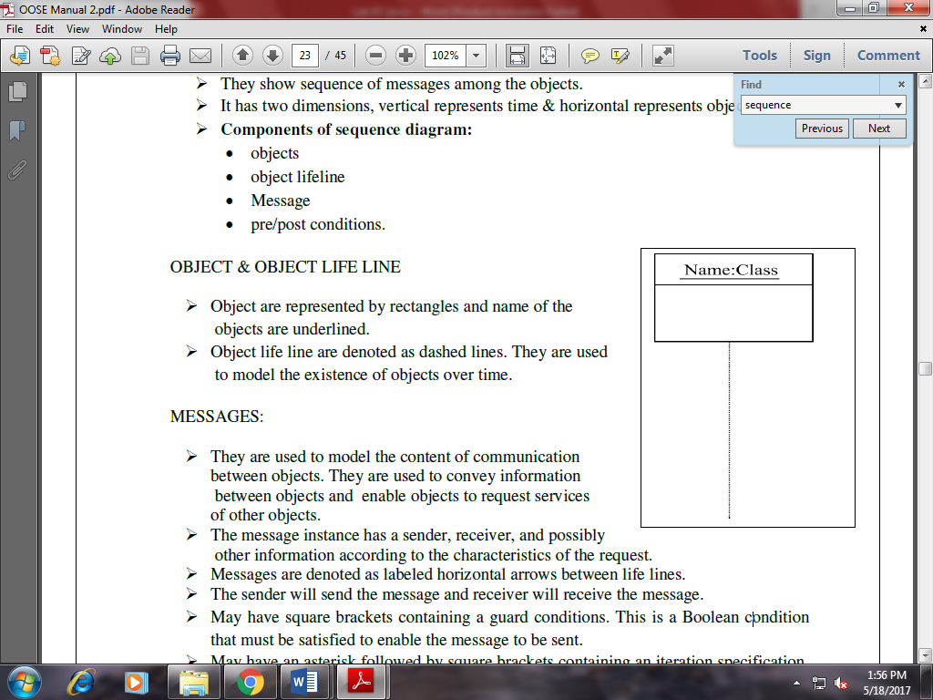

**MESSAGES:**

* They are used to model the content of communication between objects. They are used to convey information between objects and enable objects to request services of other objects.
* The message instance has a sender, receiver, and possibly other information according to the characteristics of the request.
* Messages are denoted as labeled horizontal arrows between life lines.
* The sender will send the message and receiver will receive the message.
* May have square brackets containing a guard conditions. This is a Boolean condition that must be satisfied to enable the message to be sent.
* May have an asterisk followed by square brackets containing an iteration specification.

This specifies the number of times the message is sent.

* May have return list consisting of a comma -separated list of names that designate the values of returned by the operation.
* Must have a name or identifier string that represents the message.

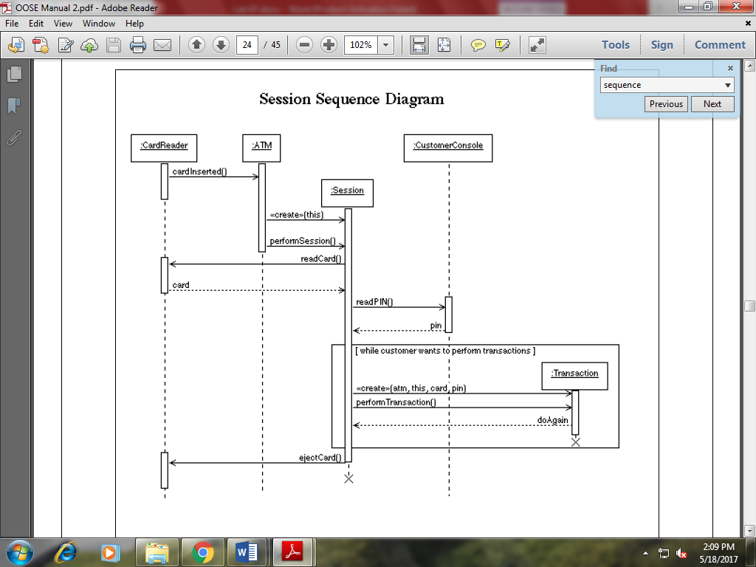

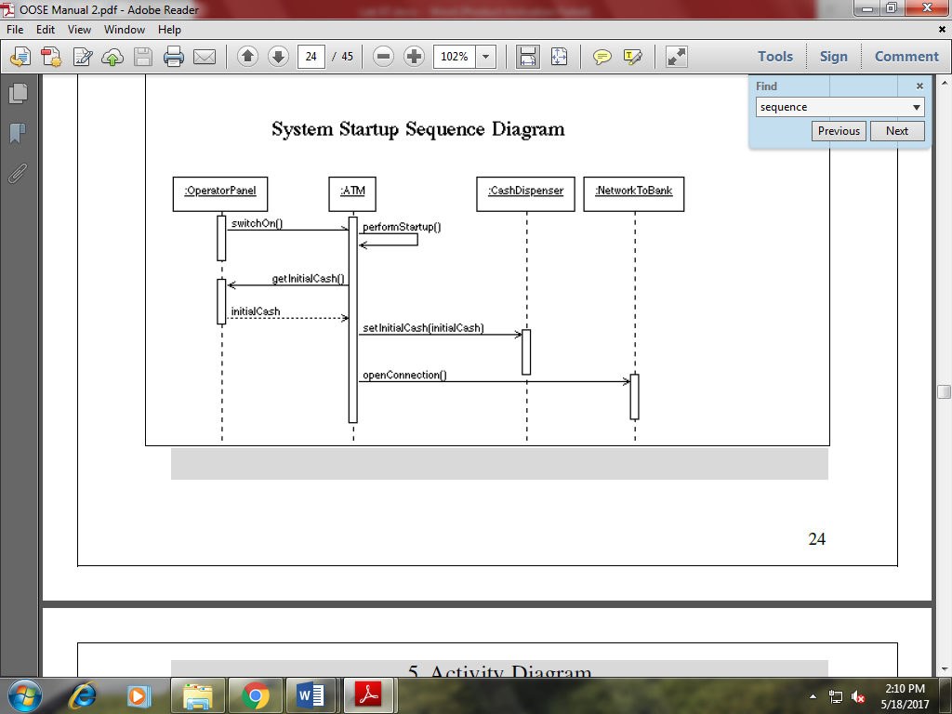

**Lab Task:**

1. Draw sequence diagram and Collaboration diagram for ATM machine
2. Draw sequence diagram and Collaboration diagram for Library Management system